Contrast Enema

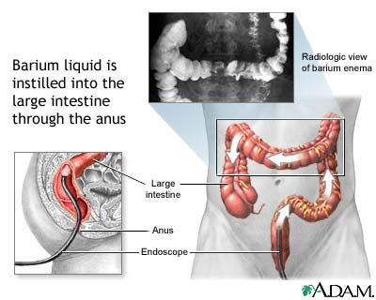
What is it?

A contrast enema is a special x-ray and enema solution of the lower part of the intestines (large intestines).

What to expect?

It is done in the radiology department of the hospital. Your child should not have anything to eat or drink after midnight until the time of the test.
Once you arrive, first your child will lie on their back and an x-ray will be taken.
Next they will lie on their side while a small lubricated tube is placed in the rectum through the anus. The tube is connected to a bag or syringe filled with contrast, which will flow into the rectum. Contrast is a liquid that helps highlight areas of the body. They will be asked to move in different positions and the table may be tipped to obtain different views. It is not a painful test, but will probably be uncomfortable for the child, so expect some crying.

Why does my child need this?

A contrast enema is a helpful study to diagnose and understand abnormalities of the large intestine.
Barium Enema Phone Number 215-427-5235
Any risks?
Questions for the Radiologist:
1.
2.
3.
4;
5.

Since a contrast enema is a special x-ray, the child is at risk for low radiation exposure. Children may feel constipated afterwards. You can prevent this by encouraging your child to drink lots of water. Your child’s bowel movements remain white for a few days after the exam, which is normal.

St. Christopher’s Center for Child and Adolescent Health
Developed May 2011 by Nina Sivadasan-Nair, MD

