VCUG
(Voiding Cystourethrogram)

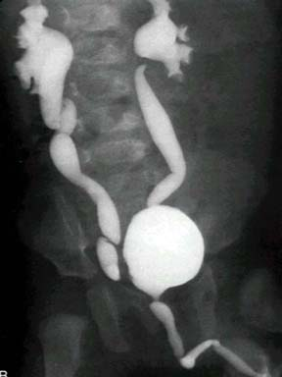
What is it?

A VCUG is a study that uses X-Rays to study your child’s urinary system. The urinary system is: the kidney, the ureters (two tubes that connect the kidneys to the bladder) the bladder, and the urethra (goes from the bladder to outside the body).

What to expect?

The area between your child’s legs will be cleaned, and a catheter (small rubber tube) will go into the urethra (where the urine comes out), and then into the bladder.
Cystograffin (a clear liquid) will go through this catheter and into the urinary system.
Then, X-Ray pictures will be taken. This will not hurt and allows the doctors to see the contrast on a monitor.

Why does my child need this?

To check for certain problems with the bladder (like a blockage) as well as
to make sure the urine is going in the right direction. Sometimes, the urine goes backwards towards the kidneys instead of forward which is the normal way (this is called reflux). This can cause UTIs (urinary tract infections).

Any risks?

The radiation with a VCUG is small. Radiology Phone Number 215-427-5579
Care is taken to use as little radiation as possible, using pediatric dosing.
Questions for the Radiologist:
1.
2.
3.
4.
5.
St. Christopher’s Center for Child and Adolescent Health
Developed May 2011 by Ashley Altman, DO

