Upper GI
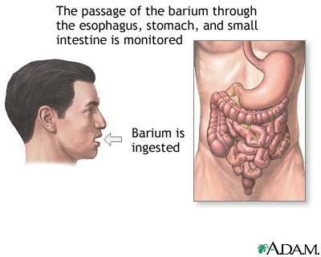
What is it?

A test using x-rays to help figure out problems of the esophagus (feeding tube that comes after the mouth), stomach and small bowels.

What to expect?

The stomach must be empty before the x-rays are taken. No eating or drinking for 8 hours before. The patient then stands in front of an x-ray machine and drinks barium (a white chalky tasting liquid) so that diseases of the esophagus, stomach, or bowels, can be seen easier on x-rays. An x-ray video is used to watch how the barium liquid moves down the throat, into the esophagus, then stomach.

Why does my child need this?

An upper GI can help tell if your child has problems like gastroesophageal (acid) reflux, slowness of the bowels (delayed gastric emptying) , or anything that is pushing on the esophagus or problems with the stomach or small bowels.

Any risks?

Your child may become constipated from the barium so it is good to drink lots of water after the study.
Questions for the Radiologist:
1.
2.
3.
4.
5.
Radiology Phone Number
215-427-5579
St. Christopher’s Center for Child and Adolescent Health
Developed May 2011 by Grace Appiah, MD

