**The Diagnosis and Management of the Initial Urinary Tract Infection in Febrile Infants and Young Children 2–24 Months of Age**

Summary of the 2011 and 2016 AAP Clinical Practice Guidelines

**DIAGNOSIS:**

When evaluating a febrile infant between the ages of two months and twenty-four months, always consider the risk of UTI. Risk can be calculated by evaluating for various factors. For girls, risk factors include white race, age less than twelve months, temperature greater than or equal to thirty-nine degrees Celsius, fever greater than or equal to two days, and absence of another source of fever (see Figure 2). For boys, risk factors include non-black race, temperature above or equal to thirty-nine degrees Celsius, fever longer than twenty-four hours, and absence of another source of infection (see Figure 2). 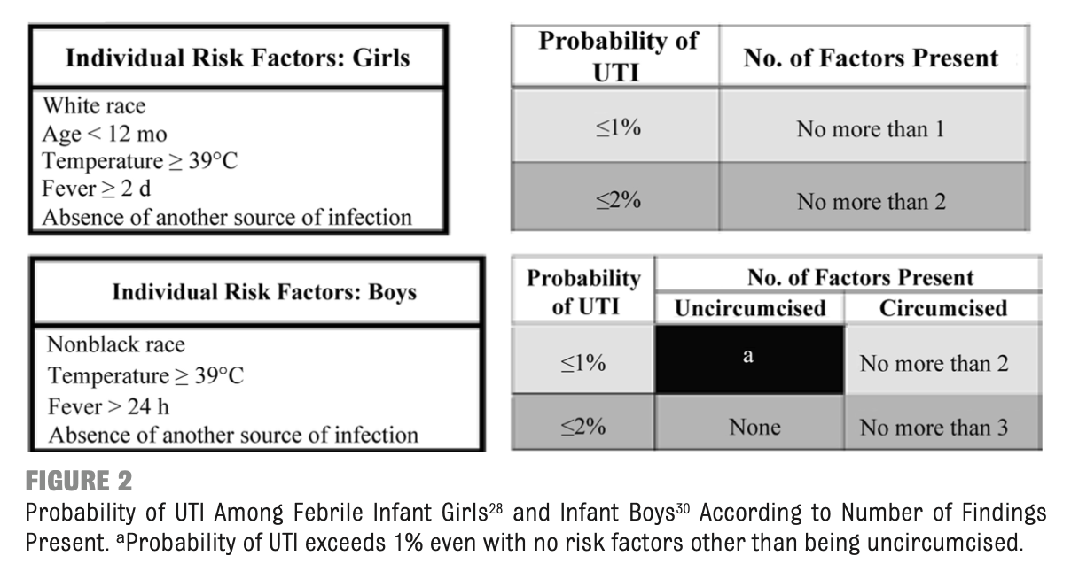

Leukocyte esterase is the most sensitive individual component on urinalysis for UTI (83%) and nitrites are the most specific individual component on urinalysis (98%) (see Table 1).

If there is a low likelihood of UTI, you can watch the child clinically OR obtain a urinalysis via a convenient method such as clean catch/bag. If the urinalysis is negative, there is no need to obtain a culture. If it is positive, however, culture must be obtained via suprapubic aspiration or catheter to obtain clinically significant results.

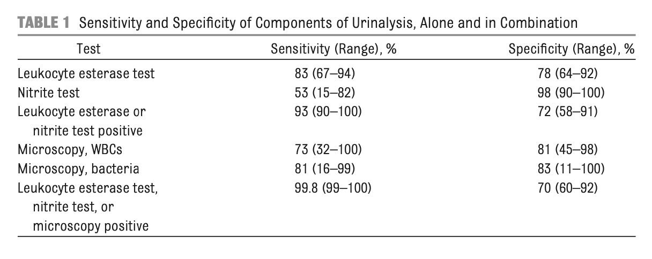

If the likelihood of UTI is deemed to be high, then obtain a urinalysis and urine culture via suprapubic aspiration or catheter *before* antibiotic administration. Diagnosis of UTI is made via pyuria (white cells on urinalysis) and over fifty-thousand colony-forming units on culture.

**MANAGEMENT:**

Antibiotics should only be started after a urinalysis and culture are collected. Oral and parenteral routes are equally efficacious. Antibiotics should be selected based on local resistance patterns as they can vary significantly via geography (Table 2A) and then subsequently adjusted based on culture sensitivities.

Table 2A:

|  |  |
| --- | --- |
| **IV Antibiotic/PO equivalent** | **St. Christopher’s *E. coli* Susceptibility 2018-2019** |
| Ceftriaxone/Cefixime | 94% |
| Cefazolin/Cephalexin | 78% |
| Ampicillin-Sulbatam/Amoxicillin-Clavulanic Acid | 55% |
| Trimethoprim-Sulfamethoxazole | 72% |

Common choices include cephalosporins, amoxicillin-clavulanic acid, or trimethoprim-sulfamethoxazole (see Tables 2-3). Antibiotics should be given for a seven- to fourteen-day course.

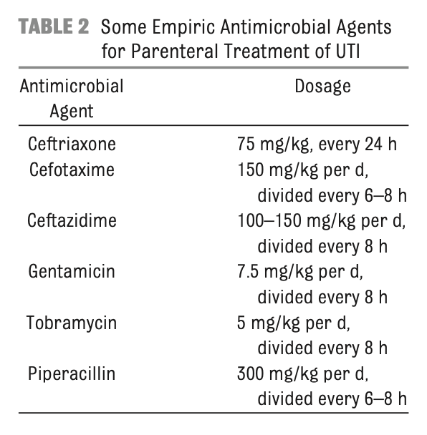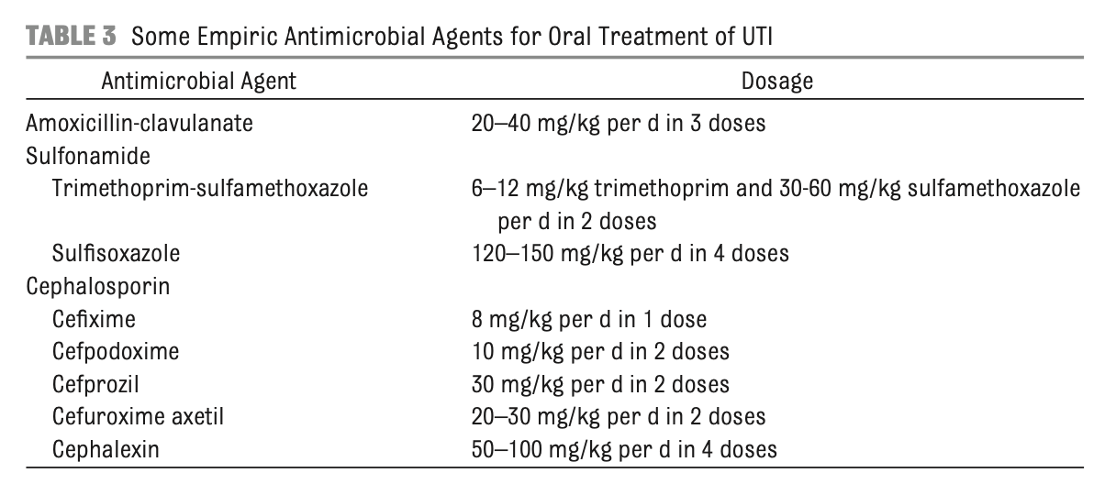

**FOLLOW-UP/PATIENT EDUCATION:**

Infants with febrile UTI should undergo renal and bladder ultrasound within forty-eight hours to evaluate for anatomic abnormalities. It is important to note that in infants who demonstrate good clinical improvement, renal and bladder ultrasound can and should be delayed because acute infection can sometimes produce misleading transient dilation. If the ultrasound uncovers hydronephrosis, scarring, or other findings suggestive of high-grade vesico-ureteral reflux (VUR) or obstructive uropathy, obtain a voiding cystourethrogram (VCUG).

For future febrile illnesses, parents should be encouraged to seek medical care for their child within forty-eight hours to ensure infections can be promptly diagnosed and treated. If a second UTI occurs, consider imaging studies.