**Tips for Exclusively Pumping**

Pumping:

* Pump both breasts at the same time (if you can) for 15-20 minutes, even if you don’t see milk
* Try to pump at least every 2-3 hours during the day and several times at night to keep milk moving
* To increase flow: put warm towel on chest, massage breasts, skin-to-skin contact, look at picture of your baby
* For irritation/discomfort:
  + Make sure you are using the correct size flange
  + Try reducing suction – only go as high as you’re comfortable
  + Can put olive olive or coconut oil on nipples before pumping

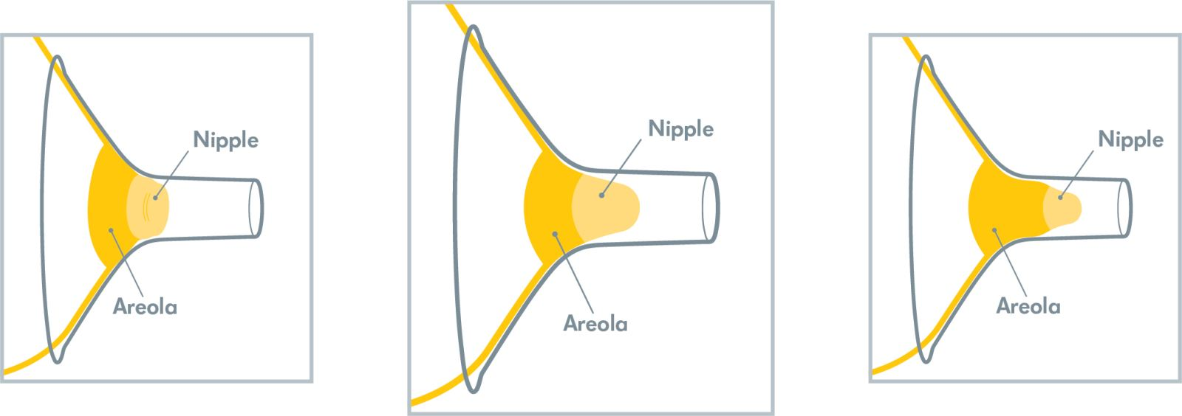

Too big

Too small

Correct size!

Milk Storage:

* Room temperature 4 hours, refrigerator 4 days, freezer 6-12 months (in deep freezer)
* Freeze 3-4oz portions so they are easier to thaw

Bottle Feeding

* Hold baby in upright position with bottle almost horizontal
* Bottle should take at least 10 minutes to feed, give lots of burp breaks during feed
* 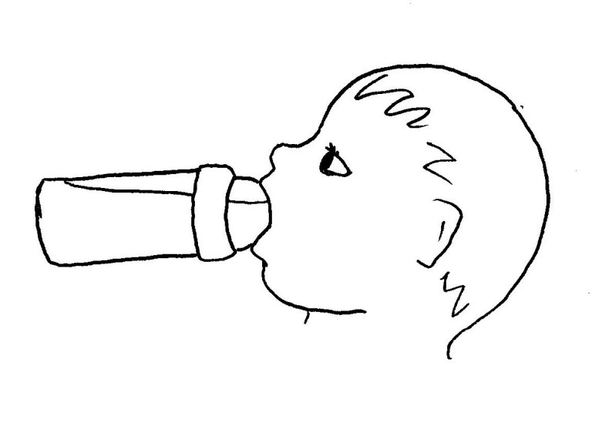Use slow flow nipples to decrease risk of overfeeding