Renal (Kidney) Ultrasound
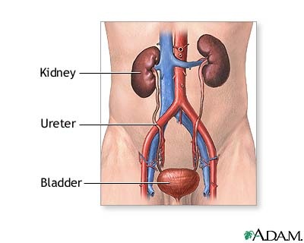
What is it?
A renal (kidney) ultrasound is a painless test that uses sound waves to take pictures of the kidney, ureters and bladder. The kidneys are bean-shaped organs that remove waste from the body by making urine. The urine then moves from the kidney to the ureters, which are thin tubes that bring the urine to the bladder. The bladder holds the urine until you are ready to urinate.

The ultrasound machine uses sound waves that you cannot hear. The sound waves bounce off organs in the body and are recorded in the machine as black-and-white pictures. These pictures show the structure of the kidneys, bladder and nearby organs.

What to expect?
The ultrasound is just like the ultrasound pregnant women receive. You will bring your child to the radiology department, where he or she will be brought to the ultrasound room. Your child will change into a gown and lie on a table. The ultrasound technician will place gel on your child’s belly and lightly press a wand over the gel. The wand sends out sound waves into the belly. Your child will not feel them. The sound waves bounce back to the wand, and the machine forms pictures. Your child will need to stay still during the test. A doctor may come in during the ultrasound to take more pictures. The test usually takes less than 30 minutes. Your doctor should get the results within 1-2 days.
Questions for the Radiologist:
1.
2.
3.
4.
5.
Why does my child need this?
The renal ultrasound is used to look for problems with the kidneys or bladder. These problems could be caused by infection, stones or differences in size or shape present since birth. The test will look at the size and shape of the kidneys,
signs of injury, changes to the kidneys present since birth, kidney or bladder stones, and cysts or tumors of the kidneys or bladder.

Any risks?
This test is painless and there is no risk to your child. There is no radiation involved. You should be able to stay with your child to provide support during the test.
St. Christopher’s Center for Child and Adolescent Health
Developed May 2011 by Erin Milligan-Milburn, MD
Ultrasound Phone Number 215-427-5225

