MLP in REDCap - 2021

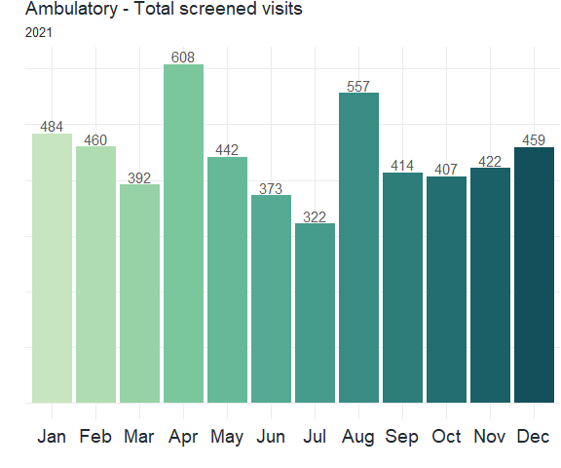

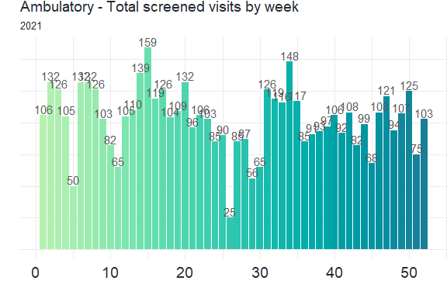

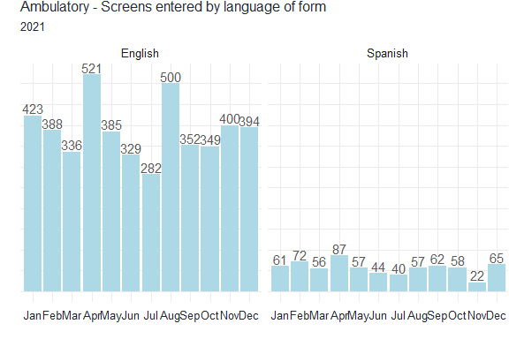

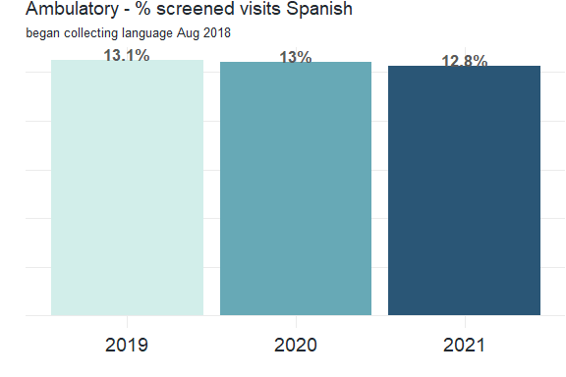

|  |  |  |  |
| --- | --- | --- | --- |
| year | screens | span | percent_span |
| 2019 | 5904 | 775 | 13 |
| 2020 | 5709 | 741 | 13 |
| 2021 | 5340 | 681 | 13 |

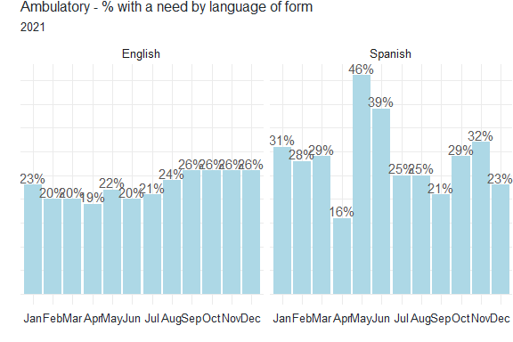

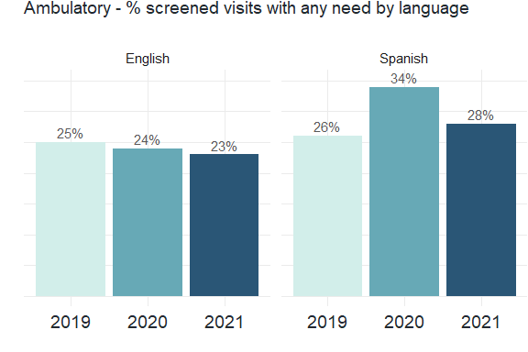

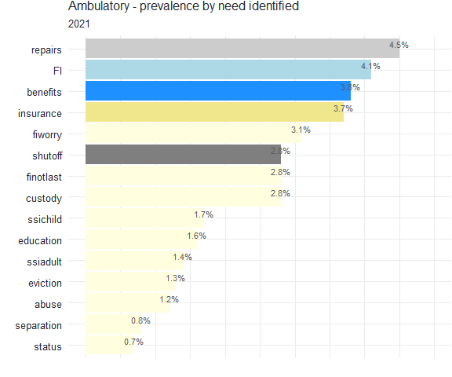 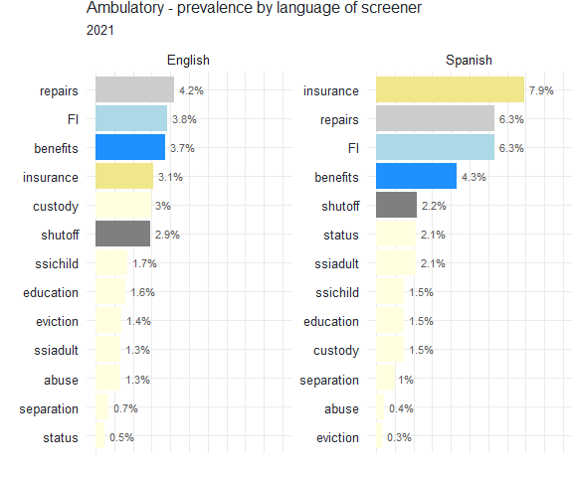

# Totals

|  |  |  |  |  |
| --- | --- | --- | --- | --- |
| month | forms | sibs | total_screens | anyneed |
| Jan | 484 | 53 | 537 | 117 |
| Feb | 460 | 39 | 499 | 99 |
| Mar | 392 | 41 | 433 | 84 |
| Apr | 608 | 60 | 668 | 111 |
| May | 442 | 61 | 503 | 112 |
| Jun | 373 | 33 | 406 | 82 |
| Jul | 322 | 40 | 362 | 70 |
| Aug | 557 | 69 | 626 | 132 |
| Sep | 414 | 56 | 470 | 105 |
| Oct | 407 | 50 | 457 | 106 |
| Nov | 422 | 46 | 468 | 109 |
| Dec | 459 | 50 | 509 | 119 |
| Total | 5340 | 598 | 5938 | 1246 |

# by question

|  |  |  |  |  |  |  |  |  |
| --- | --- | --- | --- | --- | --- | --- | --- | --- |
| month | repairs | eviction | ssichild | ssiadult | benefits | status | separation | custody |
| Jan | 28 | 17 | 32 | 38 | 33 | 15 | 13 | 24 |
| Feb | 25 | 14 | 20 | 15 | 26 | 10 | 12 | 20 |
| Mar | 24 | 11 | 20 | 14 | 26 | 12 | 13 | 21 |
| Apr | 23 | 8 | 13 | 8 | 36 | 8 | 8 | 34 |
| May | 27 | 12 | 15 | 17 | 28 | 9 | 12 | 14 |
| Jun | 13 | 1 | 18 | 20 | 19 | 8 | 1 | 13 |
| Jul | 24 | 6 | 8 | 9 | 18 | 6 | 5 | 10 |
| Aug | 42 | 19 | 21 | 20 | 37 | 14 | 18 | 23 |
| Sep | 38 | 18 | 20 | 22 | 30 | 11 | 12 | 17 |
| Oct | 32 | 21 | 31 | 29 | 35 | 36 | 27 | 37 |
| Nov | 32 | 17 | 10 | 13 | 23 | 12 | 13 | 24 |
| Dec | 53 | 25 | 29 | 23 | 36 | 10 | 13 | 26 |
| Total | 361 | 169 | 237 | 228 | 347 | 151 | 147 | 263 |

# by question part2

|  |  |  |  |  |  |  |
| --- | --- | --- | --- | --- | --- | --- |
| month | shutoff | insurance | fiworry | finotlast | edu | safety |
| Jan | 14 | 34 | 28 | 25 | 24 | 17 |
| Feb | 25 | 28 | 22 | 23 | 19 | 14 |
| Mar | 17 | 22 | 20 | 20 | 18 | 19 |
| Apr | 28 | 17 | 21 | 20 | 14 | 15 |
| May | 25 | 26 | 16 | 13 | 8 | 6 |
| Jun | 23 | 10 | 17 | 11 | 9 | 10 |
| Jul | 26 | 14 | 11 | 15 | 10 | 1 |
| Aug | 36 | 45 | 23 | 24 | 23 | 20 |
| Sep | 41 | 21 | 16 | 20 | 17 | 16 |
| Oct | 38 | 39 | 25 | 34 | 39 | 29 |
| Nov | 40 | 33 | 23 | 22 | 17 | 10 |
| Dec | 37 | 40 | 24 | 24 | 26 | 16 |
| Total | 350 | 329 | 246 | 251 | 224 | 173 |