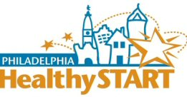
Community Resource Centers
Healthy Start has 4 community resource centers. The centers provide new mothers, fathers and babies with a safe place to get personal support, learn about services, and connect with other women and families.
Resource center services include:
- health education materials
- breastfeeding support
- help applying for TANF, Medical Assistance, and Food Stamps
- help with job readiness and employment services
- help with education and returning to school
- support for fathers
- help finding emergency food cupboards and pantries
- housing referrals
- referrals for domestic or family violence services

Locations
In North/Northwest Philadelphia
Health Center 5
1900 N 20th street
215-685-2457
9 am – 5 pm
In West Philadelphia
4119-21 Lancaster Avenue
215-386-3390
9 am – 5 pm

In South Philadelphia
Intercultural Family Services
2317 S 23rd Street
215-463-4673
In Southwest Philadelphia
5548 Chestnut Street
215-471-3251
hours by appointment

Call us today!
A Healthy Start Outreach Coordinator can help you get the care you need.
215-685-5268

