For staff use - Child’s MR #: Today’s date:

DO YOU NEED FREE LEGAL HELP?

Welcome to the Center for Child and Adolescent Health (CCAH). We are committed to improving the health and well-being of our patients and their families. In our efforts to address the unmet needs of many of our families we have developed a relationship with a program called PhilaKids MLP. This program allows us to work together with lawyers in our office, in order to make sure that children and families get all the help that they might need.
Please complete this form to help us see if this program can help you. If any of the questions make you feel uncomfortable, please don’t answer them. * Your answers are private *

********* Please hand the form to your nurse or doctor when completed.*********

1. Housing/Utilities Please answer Yes or No Below
a) Do you have problems with your LANDLORD getting home repairs (mold, rodents, leaks)? Yes No (L)

b) In the past 30 days, has your LANDLORD threatened to evict you or turn off utilities? Yes No (L)

c) Have you received a shut off notice from any utility (gas, electric, water) in the past 30 days?
[] Utility Resources Given Yes No (P)
2. Income/Insurance Supports
a) Is there someone in your home who doesn’t have health insurance? [] Insurance Resources Given
Yes No (P)

b) Have you been denied in the past 90 days SSI for your child? Yes No (L)
c) Have you been denied in the past 90 days Social Security benefits (SSI/SSD) for yourself? Yes No (L)

d) Within the past 12 months we worried whether our food would run out before we got
money to buy more. [] Food Resources Given Yes No (P)
e) Within the past 12 months the food we bought just didn’t last and we didn’t have money to
get more. [] Food Resources Given Yes No (P)

f) Have your food stamps, WIC, or cash assistance stopped or been reduced and you don’t
know why? Yes No (L)

3. Education
a) Are you having trouble getting the school to meet your child’s educational needs or to follow
your child’s IEP or 504 plan? [] Education Resources Given Yes No (P)
(Consider MLP)
4) Legal Status
a) Do you have any questions about your family’s immigration status? Yes No (L)

5) Personal and Family Safety and Stability
a) Have you ever been hit, threatened, or abused by a boyfriend, girlfriend, or spouse? Yes No (S)

b) Do you want information about separating from your spouse or getting a divorce? Yes No (L)

c) Do you have concerns about child support or custody of your child(ren)? Yes No (L)

Providers. For any “Yes” answers please:
- If it’s ANY questionnaire with a (L) at the end (legal) of the question, and the family wants to talk to the MLP, please have the parent/caregiver sign this form and call x5343 or x8146 or go to MLP office.
- If it’s a question that only has a (S) at the end, please consult Social Work.
- If the any of the Insurance, Food Insecurity or Utility questions (2a) (2d) (2e) or (1c), are a “yes”, please give resources AND indicate on the form that you gave the resources.
If the family cannot speak with MLP today, please give them the MLP business cards or the MLP/LCD INTAKE flier.

I authorize St. Christopher’s Hospital for Children to provide my name and contact information to the attorneys and staff of the PHILAKids MLP/Legal Clinic for the Disabled, Inc.

________________________ __________________
Signature Date

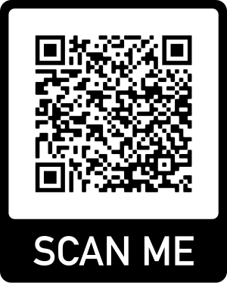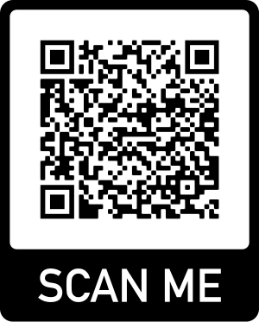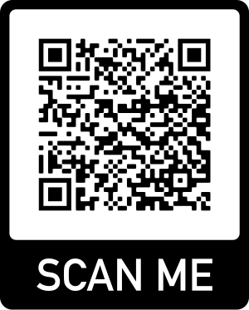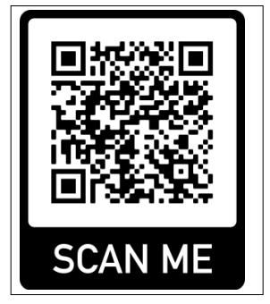
Education
Educacion
Insurance
Segura Medico
Utilities
Utilidades
Food
Comida

INSTRUCTIONS FOR MEDICAL PROVIDERS:

1. CIRCLE the QR CODES recommended to parent/caregivers and have them use their phone to scan.
2. ASSIST families by:
- Switching screen to appropriate language once linked to CAP4KIDS.ORG (options at top of screen)
- Help families bookmark resources to phone or email (instructions for iphone/android posted in office)

3. ANSWER the following questions & provide comments
What device did the family use: ___ iPhone __Android __Other / Unknown

As a medical provider, my experience giving resource information with scan codes for this patient was:

1 2 3 4 5
Very Poor ----------------------Poor--------------------------Neutral ------------------------Very Good -----------------------Excellent
(didn’t work (required too much (no preference to
gave paper handout) effort) paper handouts)

Comments:

