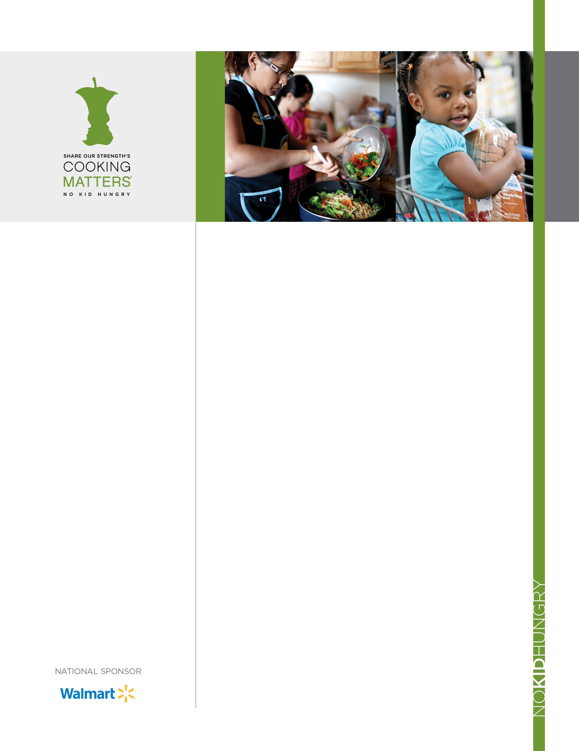­­

[](http://www.google.com/url?sa=i&rct=j&q=&esrc=s&frm=1&source=images&cd=&cad=rja&docid=P0tS5yUEo4_qJM&tbnid=W6ntBvT9uuv5uM:&ved=0CAUQjRw&url=http://www.paracleterealty.com/clients.php&ei=G7ZQUcDECaq_0gGt6oGwBQ&psig=AFQjCNEaL1GGQFGkEHbmlHLrtJiggXV3lA&ust=1364330370)

GP

**Date of Referral: _________________________________________________**

**Participant Name: _______________________________________________**

**Child(s) Name: ___________________________________________________**

**___________________________________________________**

**Notes: _____________________________________________________________**

**______________________________________________________________________**

**Every Monday – 4PM**

ShopRite of Fox Street

2800 Fox Street

Philadelphia, PA 19129

Contact: Alex E.

215.469.1716 aevenson@phmc.org

**Every Tuesday – 4PM**

ShopRite of Cheltenham Square

2385 W. Cheltenham Ave.

Philadelphia, PA 19150

Contact: Caitlin J.

267.606.0253

[cjennings@phmc.org](mailto:cjennings@phmc.org)

This material was funded by USDA”s Supplemental Nutrition Assistance Program (SNAP) through the PA Department of Human Services (DHS). This institution is an equal opportunity provider.

**FREE HEALTHY EATING ON A BUDGET GROCERY STORE WORKSHOP**

**Do you wish you could eat healthier while saving money?**

**We Can Help You:**

* Save time and money at the grocery store
* Feel confident buying healthy foods on a budget
* Plan easy and delicious meals while saving money
* Read food labels and make the best choice for your family

**After the workshop you will receive:**

* **FREE** book full of tasty recipes and simple tips on buying healthy, low-cost foods
* **FREE** reusable grocery bag
* **$10 ShopRite gift card**

.