CHW or Social Worker?

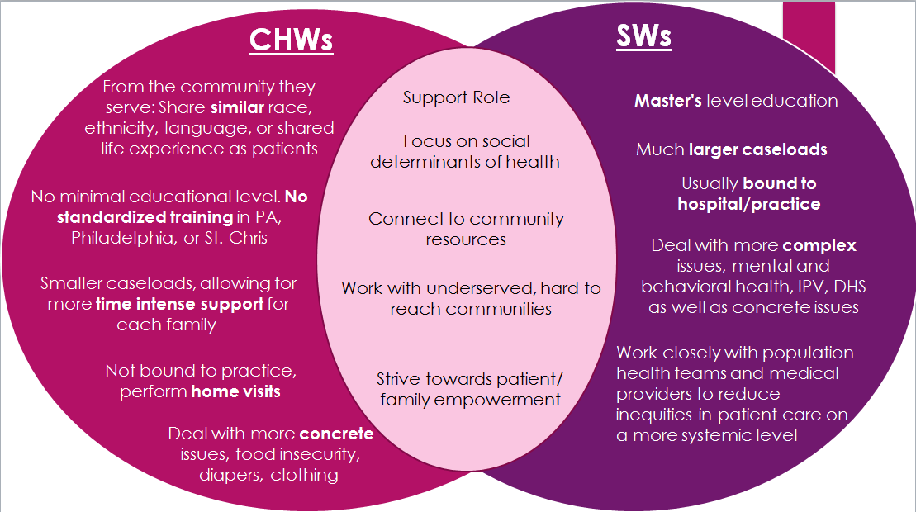

**HOW CAN A CHW HELP?**

|  |  |  |
| --- | --- | --- |
| **CHW Role** | **Responsibilities** | **Examples** |
| **Outreach/In-reach** | -Call families  -Home visits (cold knock)  -Meet families/patients in the hospital or at a specialist appointment.  -Send letters or text messages to families | -Home visit for newborn concern  -Emergency home visit (same day) if patient has concerning test results and is unreachable (telephone) and unresponsive to hospital correspondence (letters to home, text messages, emails)  -In reach if patient is in the hospital  -Introduction to CHW during visit or completing a new intake (assessment of family needs)captured at face-to-face visit |
| **Navigation and Care Coordination** | -Identify barriers to care  -Link and inform families about available community resources  -Help families enroll into programs  -Help families manage and coordinate multiple appointments and provide follow up about attending appointments  -Help with care transitions (IP, ED, transition to adult care, specialists for newly diagnosed conditions)  - Basic needs: food, clothing, utilities, housing, | -Identifying appropriate resources which best support family’s needs and help reduce barriers to care (transition to shelters, connect with local food pantries, alternative transportation services, reduced or free clothing resources, )  -Enrollment in GED programs, reduced aftercare programs, summer camps, CAP, Financial Assistance Organizations,  -Connect with parent support groups  -Assist with gaining employment, workforce training and reentry program  -Transition to adult care  -Help identify barrier when there are multiple no-shows |
| **Education/Shared Decision Making\*** | -Provide and promote culturally appropriate health and wellness education/support for chronic conditions and healthy lifestyle goals  -Teach back  -Medication management support | -Aid in communicating cultural needs, practices, and beliefs that could affect health or treatment  -Help families navigate how to identify specific after hour or weekend resources via apps and the internet  -Using teach back methods with visuals for communication with low reading literacy |
| **Social-Emotional Support/Advocate** | -Attend appointments (medical and other) with families  -Articulate and advocate the needs, questions and concerns of families back to the care team | -Attending court sessions (when appropriate) with family for emotional support  -Acting as the voice when the family feels they have no voice  -Support with language barriers  -Aid parent/caregiver who express difficulty understanding instructions from provider  -Provide emotional support to a caregiver who feels overwhelmed and has little or no support |
| **Motivation/Self-Sufficiency/ Self-Management** | -Medication management support  -Support families with care plans  - Help families with resources to improve their health like nutrition, gym memberships, Healthy Homes referrals, etc.  -Goal setting for the entire family  -Provide families with the knowledge and teach them the skills to obtain care and other services | -Going over instructions about daily medicine regimens, when to get refills, telephone reminders set to when medicine should be taken  -Identify local and community centers which provide 24 or emergency resources services (food pantry, shelter, clothing, etc.) within walking distance of home.  - Help families identify free or low-cost programs through their medical insurance plan that support wellness while experiencing a chronic illness  -Helping families create realistic goals and how to celebrate the small accomplishments  -Working with families on how to change non-productive behaviors which heighten barriers to care |

*with the support of the RN care coordinator

CHW Contact and Schedule

|  |  |  |  |
| --- | --- | --- | --- |
|  | **CHW** | **Speaks Spanish?** | **Contact Info** |
| Monday | Vanessa Martinez | Yes | * On-site in the CUC (workstation on the side near MLP) * Call Ext. need info * **Or** task Vanessa |
| Tuesday | Vanessa Martinez | Yes | Ext. 8844 |
| Yasmine Santa | Yes | Ext. 8905 |
| **OR** send a task to CHW group | | |
| Wednesday | Yasmine Santa | Yes | * On-site in the CUC (workstation on the side near MLP) * Call Ext. need info * **Or** task Yasmine |
| Thursday | Vanessa Martinez | Yes | Ext. 8844 |
| Yasmine Santa | Yes | Ext. 8905 |
| **OR** send a task to CHW group | | |
| Friday | 9am-12noon Yasmine Santa | Yes | On-site in the CUC (workstation on the side near MLP)  Call Ext. need info  **Or** task on-site CHW |
| 1pm-4pm Vanessa Martinez | Yes |
| Saturday | Please task CHW group | | |
| *Backup support to all CHWs - Tracy Christmas, Lead CHW, Ext. 3815* | | | |