Behavioral Health Resources
Did you know that the CUC and Special Needs department has behavioral health resources for patients and families?? Reach out to one of our Behavioral Health Navigators who can help patients connect to Community Behavioral Health and other resources.
What is a Behavioral Health Navigator?
A Behavioral Health Navigator (BHN) has a similar role and qualifications as a Community Health Worker with specialized training in Motivational Interviewing and behavioral health. The BHN connects families to behavioral health services by working directly with Community Behavioral Health (CBH), who are co-located at St. Chris. The BHN also screens and connects families to community resources.
What is a proper Behavioral Health Navigator Referral?
- Caregivers/child(ren) who have a Philadelphia MCO health plan.
NOTE: If family has commercial plan or uninsured, please refer to SW or Community Health Worker.
And any of the following
- There are behavioral health needs/concerns. (No Elwyn or EI referrals).
- Caregivers/child(ren) are receiving services but are not satisfied with current care.
- Family requests support with navigating BH services.
- Family was referred to CBH but has not received any updates or follow up.

How can I make a BHN referral?
Referrals need to be sent through the ordering system in EPIC. When you send a referral please include the reason for the referral.
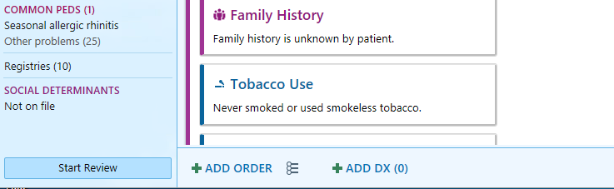
When opening a patient’s chart at the bottom of the screen there will be a “+ order” option. Click on that and type into the search bar “behavioral health navigator”.
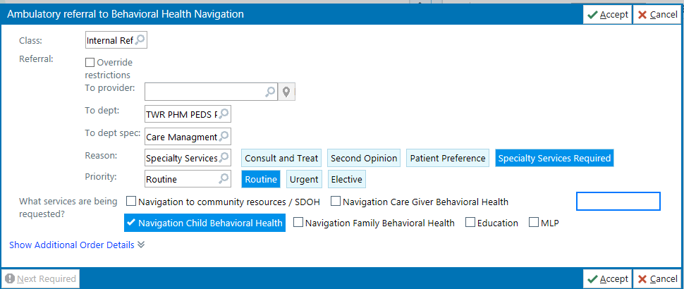
It will then take you to this box above. There is also a comment box where you can type in the reason for the referral. Once these steps are completed you then click “accept” and this referral will go directly to the behavioral health navigator’s inbox.

What should you expect when a referral is made?
- The BHN will connect with the family directly either in person or by phone.
- BHN will do an intake then connect the family directly to CBH and facilitate referrals for other social needs.
- CBH will connect family with BH services. Please keep in mind that there may be wait time when connecting families to services.
- Once family is connected to BH services, BHN receives updates and continues to case manage family as needed.
How can I get an update for a family that I referred?
- You can read the BHN notes in EPIC. The BHNs document ALL encounters/updates in the patient’s chart.
- You can direct message a BHN through EPIC.
- You can call a BHN on their cell phones for an update.
How do I contact a Behavioral Health Navigator?
You can contact a BHN through chatting us on EPIC or call/text us on our work cell phones. All of the navigators are bilingual

Where are the Behavioral Health Navigators?
Monday:
Ivette Pratts: 9am-12pm CUC’s conference room second floor
Iris Cruz: 1pm-4:30pm CUC’s conference room second floor
Ivette Pratts: 1pm-5pm Nelson Pavilion
Jasminvette Ayala: 7:30am-4pm Special Need’s work room
Tuesday:
Jasminvette Ayala: 9am-12pm CUC’s conference room second floor
Ivette Pratts: 8:30am-5pm Nelson Pavilion
Iris Cruz: 9am-5:30pm Special Need’s work room
Wednesday:
Ivette Pratts: 9am-12pm CUC’s conference room second floor
Iris Cruz: 1pm-4:30pm CUC’s conference room second floor
Jasminvette Ayala: 7:30am-4pm Special Need’s work room
Thursday:
Jasminvette Ayala: 9am-12pm CUC’s conference room second floor
Ivette Pratts: 8:30am-5pm Nelson Pavilion
Iris Cruz: 9am-5:30pm Special Need’s work room
Friday:
Iris Cruz: 9am-4:30pm CUC’s conference room second floor
Ivette Pratts: 8:30am-5pm Nelson Pavilion
Jasminvette Ayala: 7:30am-4pm Special Need’s work room

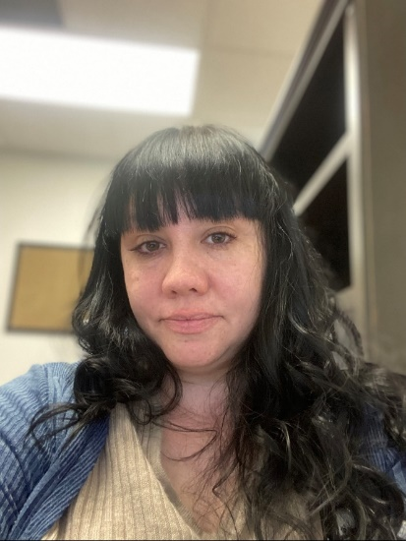
Ivette Pratts
215-341-4581
Iris Cruz
215-280-1052
Jasminvette Ayala
215-341-1963

