Meal Structure
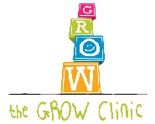

Children eat best when the meals and snacks are structured.

What do we mean by structured?
- 3 meals every day.
- 2 –3 snacks every day.
- Meals and snacks scheduled at about the same time most days.
- Eat food before drinking liquids at mealtimes.
- Eat meals and snacks while sitting
in a high chair or booster seat.
    - Try to eat meals and snacks as a family.
Children imitate family members who are also eating.
- Limit distractions such as the TV or radio during meals and snacks. Children will focus more on eating.

