St. Christopher’s Hospital for Children
Opioid Resources
Pharmacies around St. Chris that carry naloxone

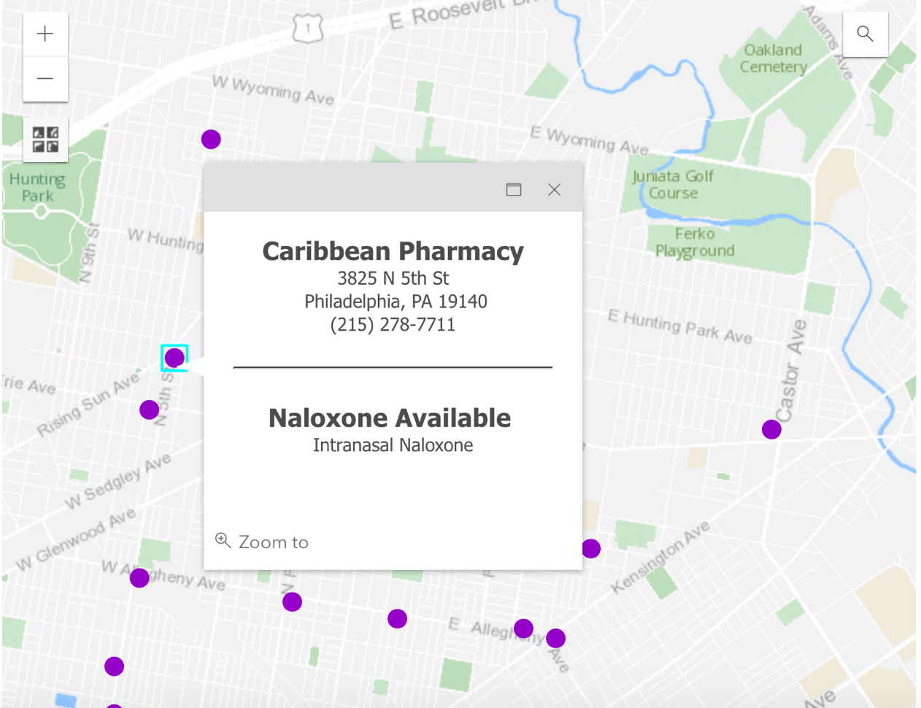

*Information obtained from: https://www.phila.gov/services/mental-physical-health/learn-how-to-get-and-use-naloxone-narcan/

Virtual Training

https://www.getnaloxonenow.org/signup.aspx

