High Fiber Foods
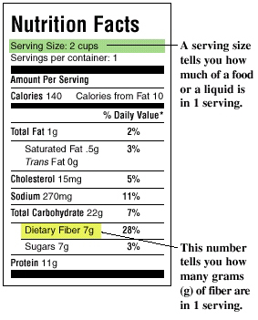

Benefits of Fiber: Fiber keeps things moving in the digestive tract and can prevent or relieve constipation. High fiber foods also help make us feel fuller for longer, and can decrease risk of obesity, diabetes, heart disease, and certain types of cancer!

Not all foods have the same amount of fiber.
Reading labels can help determine the amount of fiber per serving.

A child’s minimum daily requirement for fiber is the age in years plus 5 grams.
For example a 10-year old would need 15 (10+5) grams of fiber each day.
A 13-year old would need 18 (13+5) grams per day.

Beans: A half cup serving of beans contains about 8 grams of fiber
More examples: Baked beans, Black beans, Chick peas (Garbanzo beans), Kidney (Pinto) beans, Lima beans, Lentils, Soy Beans, White beans, Black Eyed Peas
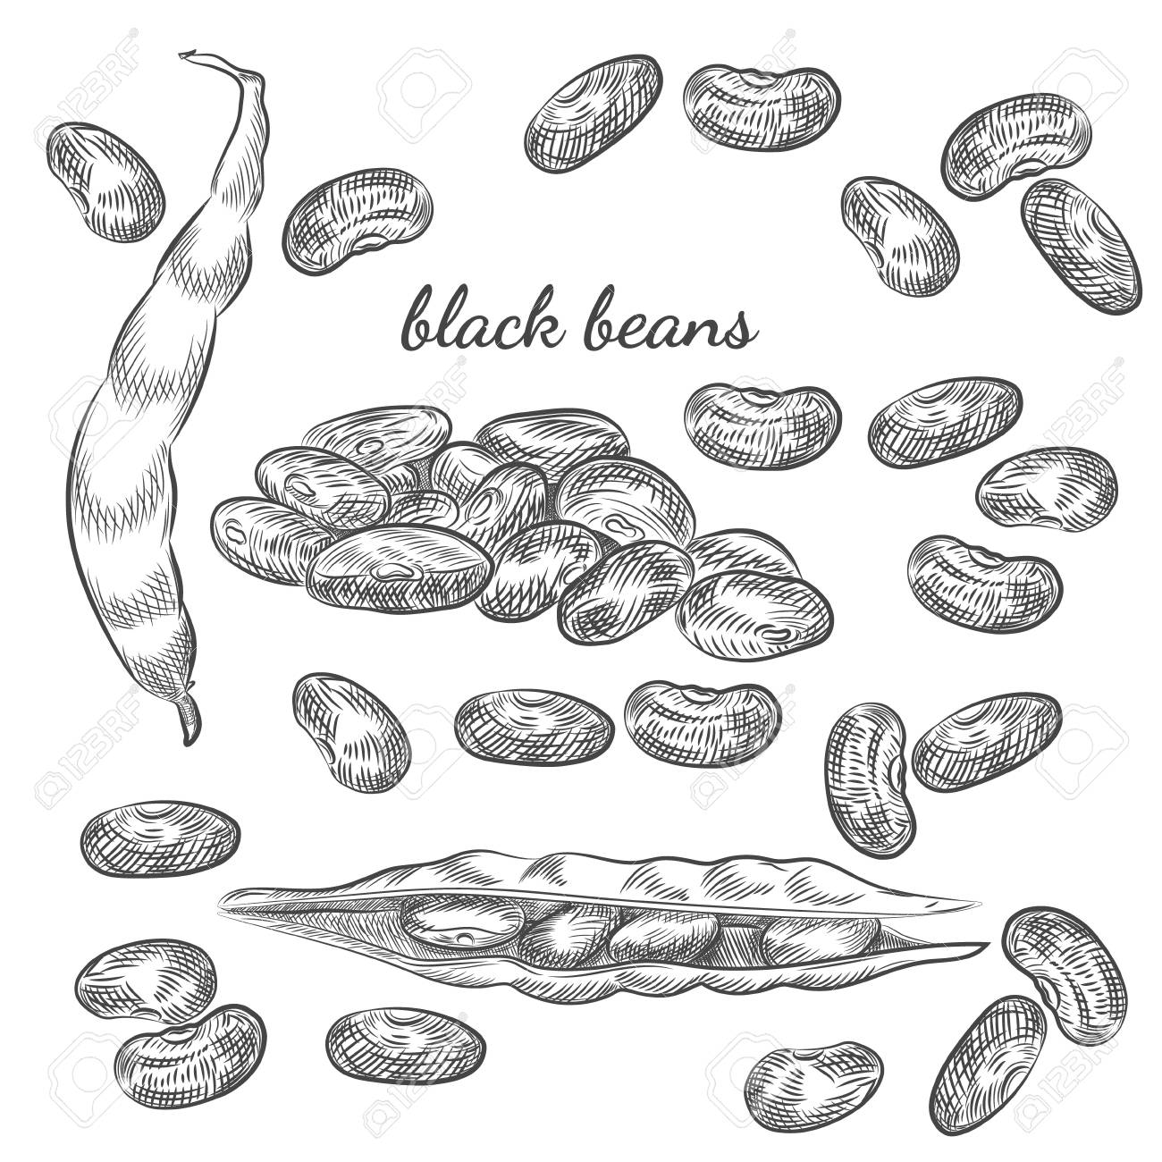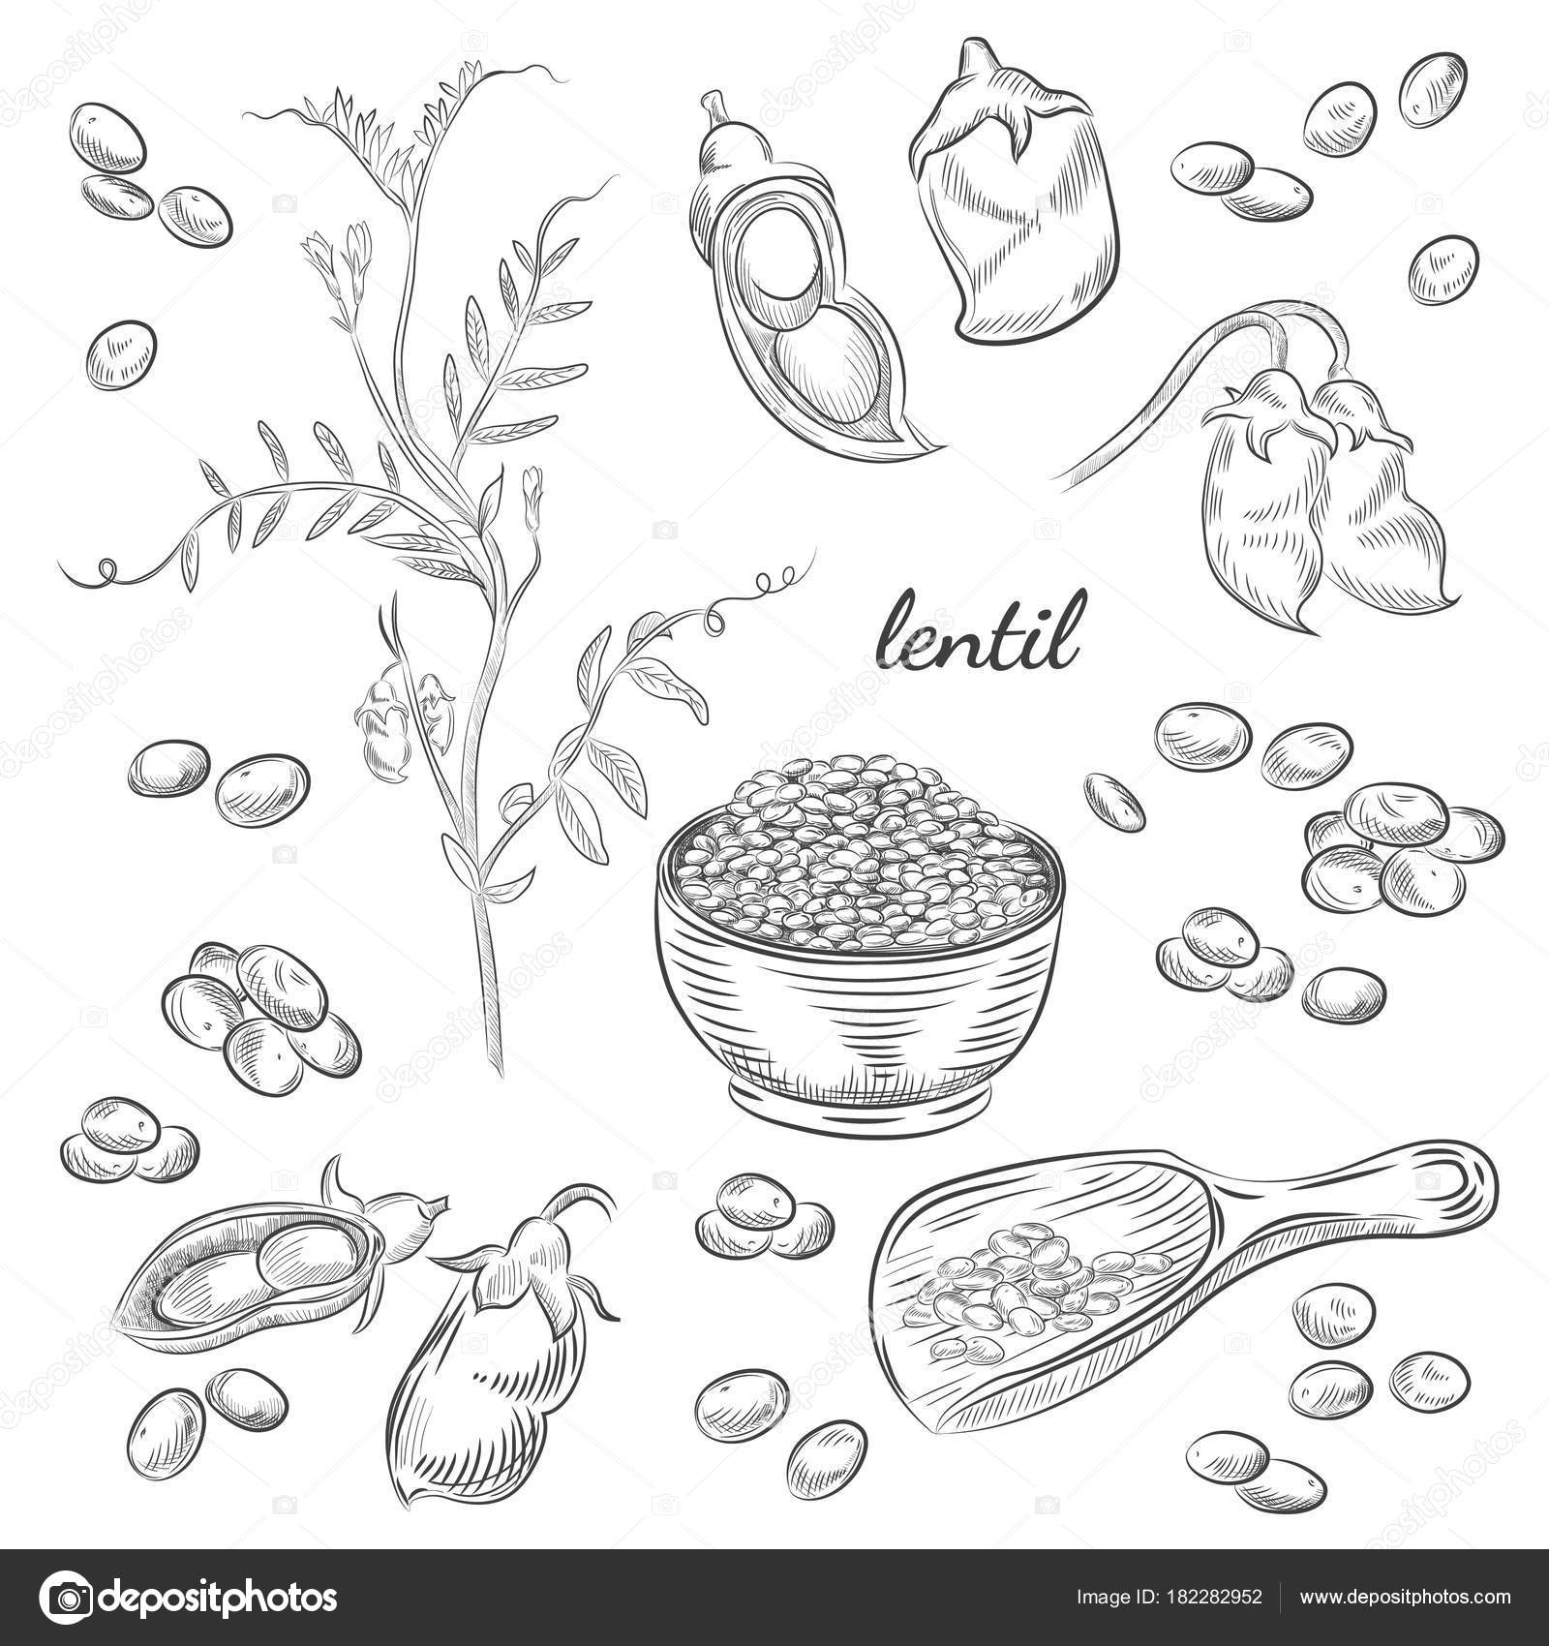
Beans and Peas (1/2 cup cooked) | Fiber (g)
Lentils | 8
Black beans | 7.5
Kidney beans | 6.5
Chickpeas (garbanzo beans) | 5.5
Soybeans (green) | 4

Fruit: A half cup serving of fruit contains about 2 grams of fiber

Fresh Fruits | Serving | Fiber (g)
Raspberries | ½ cup | 4
Banana | 1 small | 3
Blueberries | ½ cup | 2
Strawberries | ½ cup | 1.5
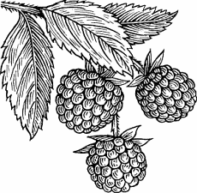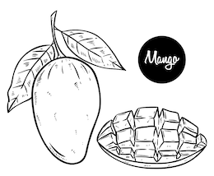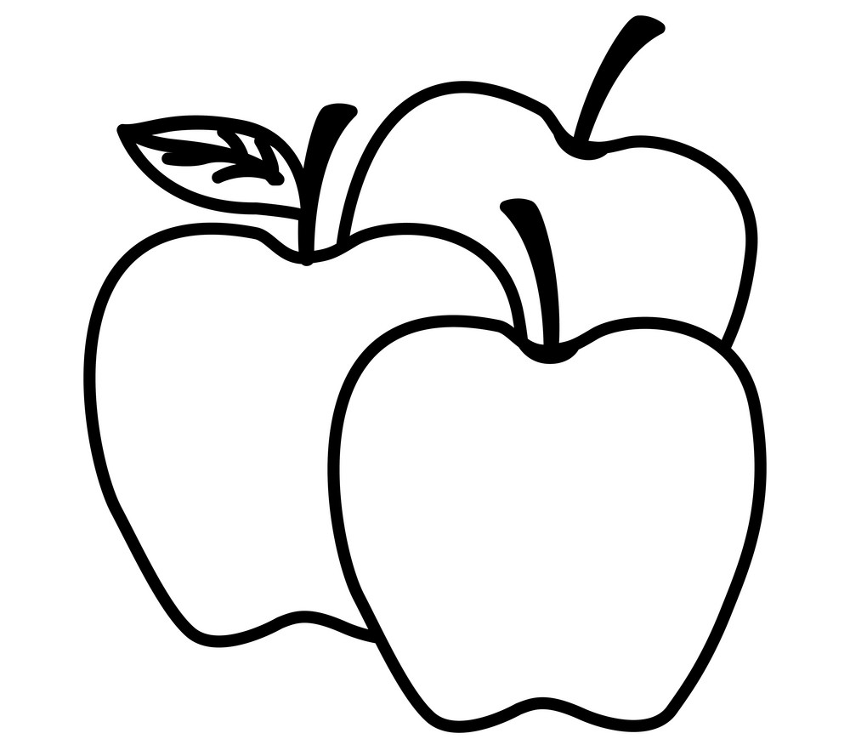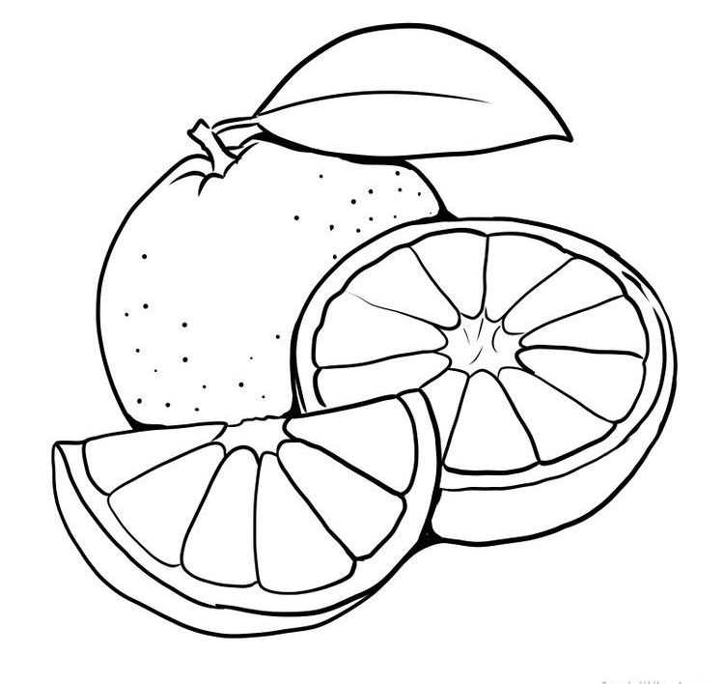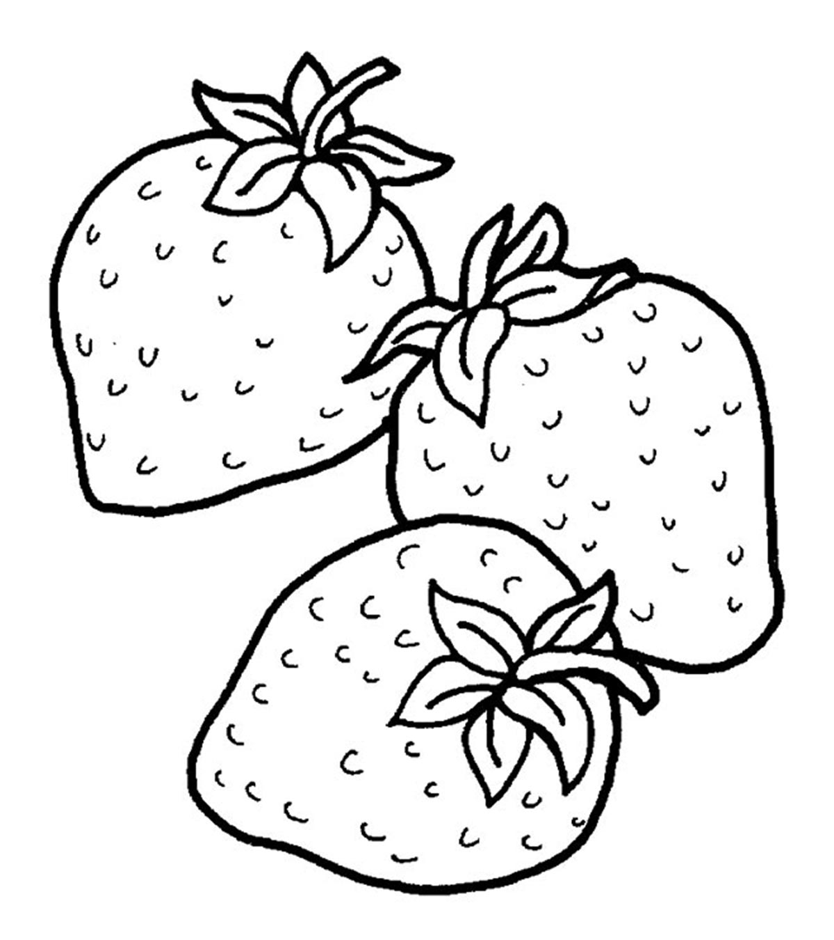
More examples: Apple with skin, Prunes, Grapes (cut into pieces), Pear, Strawberries, Clementines, Oranges, Peach, Plums, Apricots, Blackberries, Blueberries (cut in half), Raspberries, Watermelon, Cantaloupe, Honeydew, Cherries, Coconut, Dates, Kiwi, Mango, Pineapple, Papaya
- Dried fruit (for example apricots, peaches, figs, Raisins) - Watch for added sugar

Vegetables: A half cup serving of vegetables contains about 2 grams of fiber
More examples: Lettuce, Asparagus, Cucumber, Celery, Avocado, Beets, Beet greens, Cabbage, Cauliflower, Celery, Peas, Spinach, Peppers, Collards, Eggplant, Green Beans, Kale, Okra, Snow Peas, Turnip, Turnip greens, Squash, Radish, Tomato, Zucchini

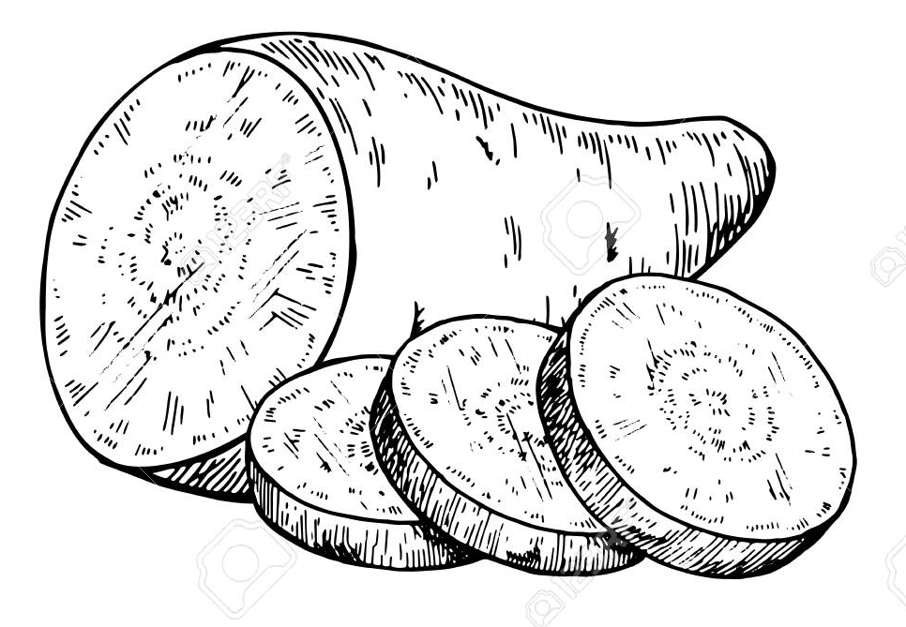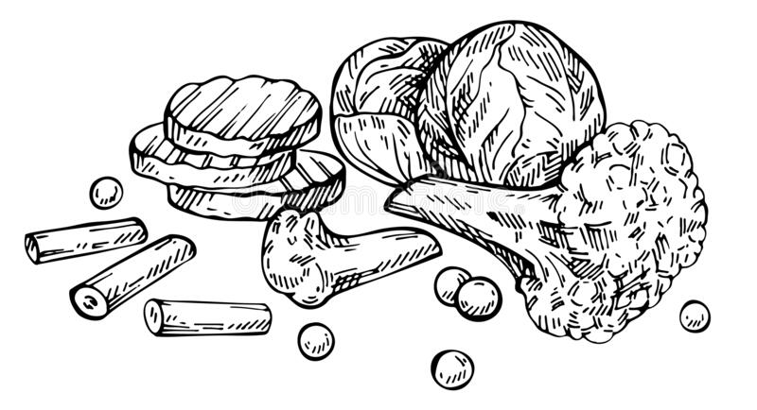
Vegetables | Serving | Fiber (g)
Sweet potato (baked, with skin) | ½ potato | 2.5
Potato (baked, with skin) | ½ potato | 2
Corn (canned) | ½ cup | 2
Carrots (raw) | ½ cup | 1.5
Peppers (sweet, green, raw) | ½ cup | 1.5
Broccoli | ½ cup | 1

Breads: One slice of wheat bread contains about 2 grams of fiber
Whole grain white, Whole-wheat, Cracked-wheat, Mixed/Multi-grain, Rye, Seven-grain, Twelve grain
Bran Muffins, Brown Rice, Cooked Barley, Corn Bread, Corn Tortilla, Whole grain bagels, Whole grain waffles
Whole wheat pasta or noodles, Chick pea or lentil pasta
Cereals: Multigrain Cheerios, Oatmeal, Grits, Raisin Bran, Cheerios, Mini-wheats, All-Bran, Bran Chex, Bran Flakes, Granola, Grape Nuts, Oat Bran, Shredded Wheat

Why whole grain is healthier:

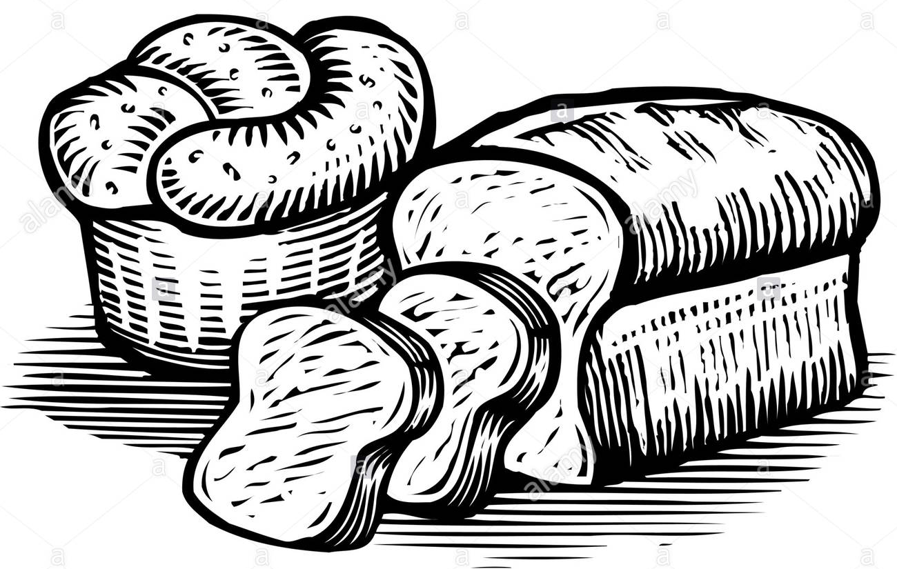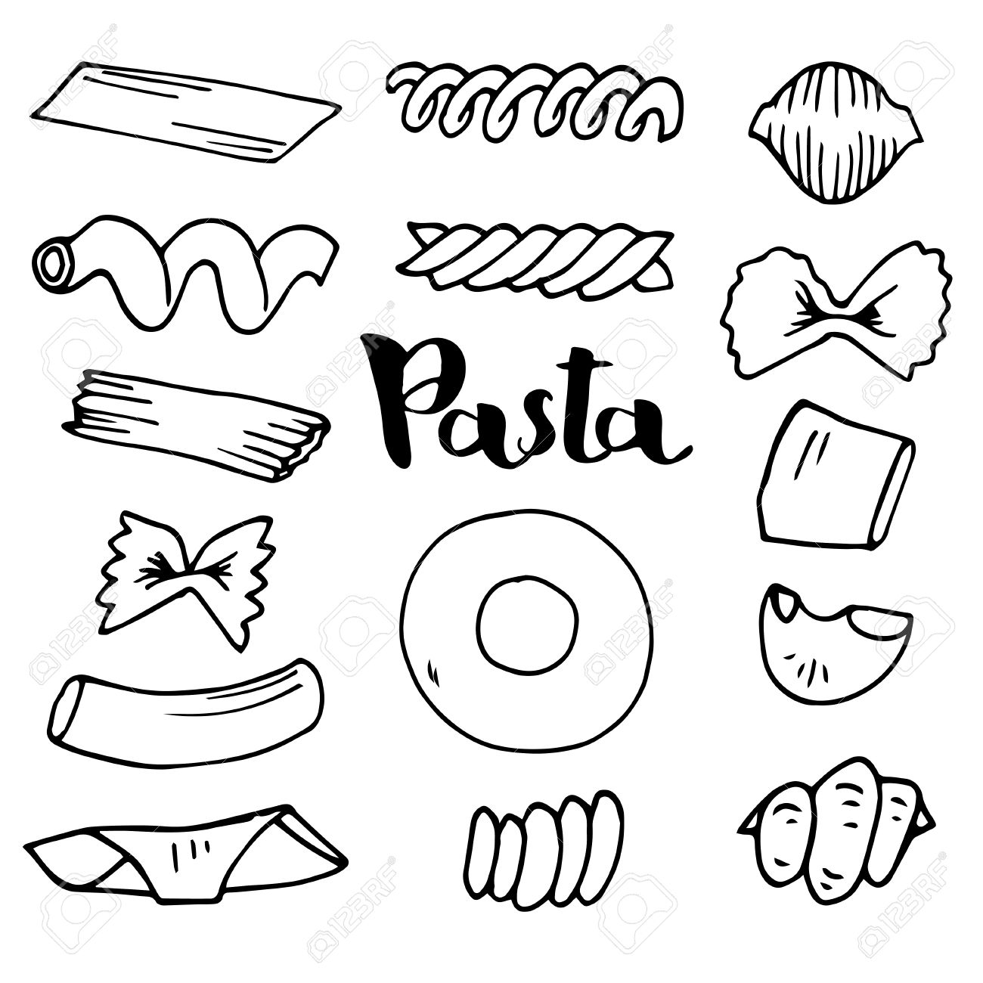
Grains (1 cup cooked) | Fiber (g)
Rice (whole grain) | 3.5
Rice (not whole grain) | 0.5
Spaghetti (whole grain) | 6.5
Spaghetti (not whole grain) | 2.5

Snacks:
Prune Juice, Fig bars, Popcorn, Graham wafers, Whole grain crackers

