Puberty & Adolescence Education Resource Guide

**Websites For Gals:**

The Center for Young Women’s Health

Powered by Boston Children’s Hospital

<http://www.youngwomenshealth.org/>

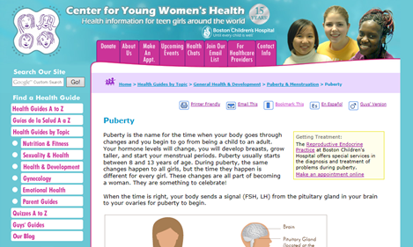

**Websites For Guys**

Young Men’s Health

Powered by Boston Children’s Hospital

<http://www.youngmenshealthsite.org/>

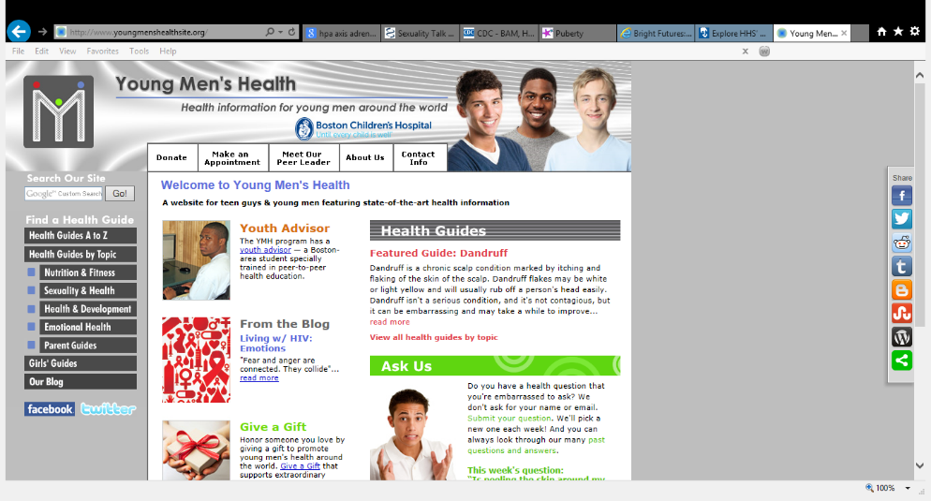

**Websites For Both**

Kids Heath / Teens Health

Powered by Alfred I. Dupont/Nemours Hospital for Children

http://kidshealth.org

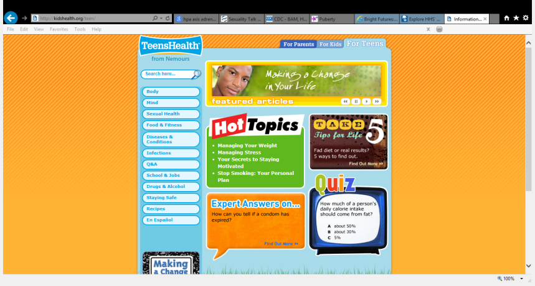

BAM! Body and Mind

Powered by the Centers for Disease Control and Prevention (CDC)

http://www.cdc.gov/bam/

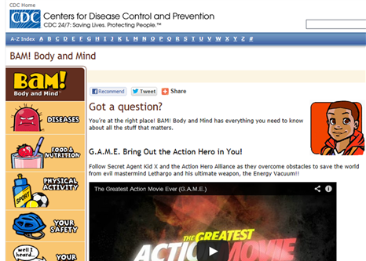

[WWW.CHOICETEENS.ORG](http://WWW.CHOICETEENS.ORG)

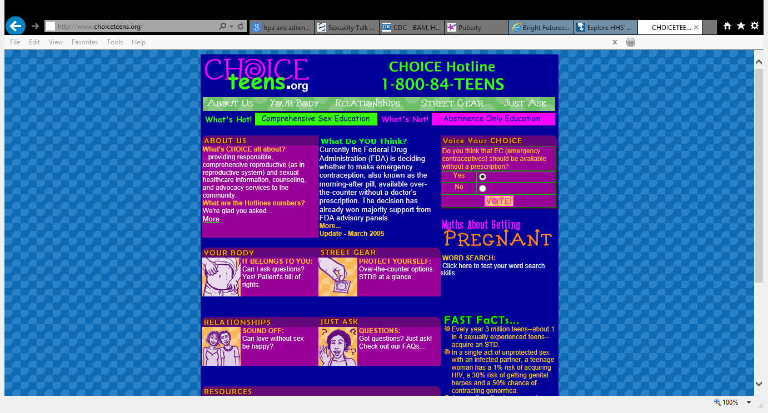

**Websites For Parents**

“Talking with your Teen”

U.S. Department t of Health & Human Services: Office of Adolescent Health

<http://www.hhs.gov/ash/oah>

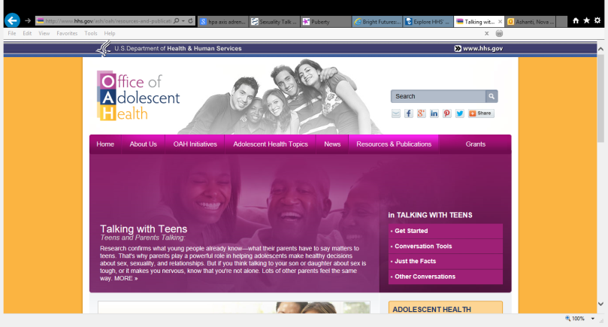

General Information for Parents of Teens

Center for Young Women’s Health

Powered by Boston Children’s Hospital

http://www.youngwomenshealth.org/parents_menu.html

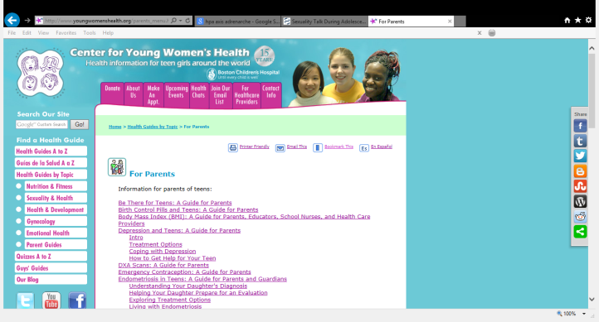

General Information for Parents of Teens

Young Men’s Health

Powered by Boston Children’s Hospital

<http://www.youngmenshealthsite.org/menu_parents.html>

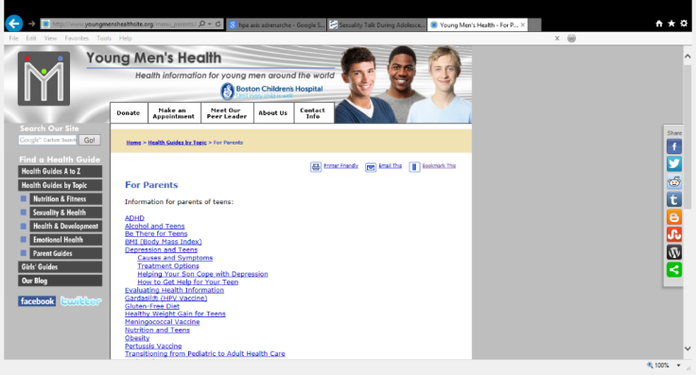

“Raising Healthy Teens”

Powered by the Centers for Disease Control and Prevention (CDC)

<http://www.cdc.gov/parents/teens/healthy_children.html>

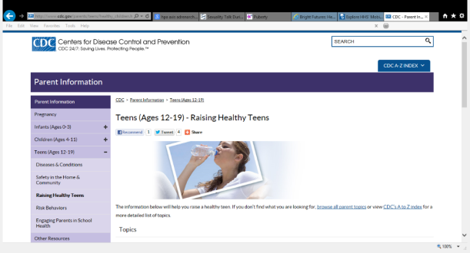

Society for Adolescent Health and Medicine (SAHM)

Health Info for Parents & Teens

<http://www.adolescenthealth.org/About-SAHM/Health-Info-for-Parents-Teens.aspx>

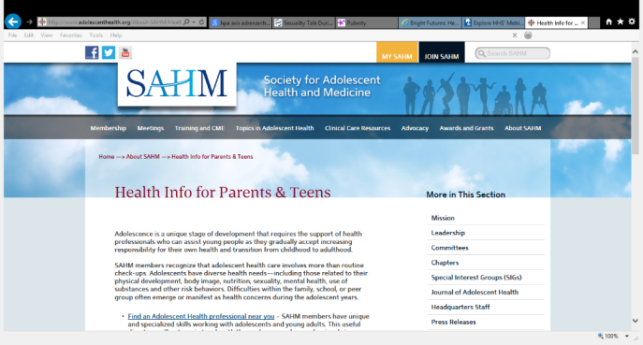

**Adolescence and Puberty in Children with Special Needs:**

The Healthy Bodies Toolkit

Powered by Vanderbilt Kennedy Center:

Leadership Education in Neurodevelopmental Disabilities (LEND)

<http://kc.vanderbilt.edu/healthybodies/index.html>

