“NoNos”
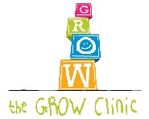

At GROW Clinic these are NoNos!
- No drinking juice!
Why? Fills up your child and has almost no nutrition.

- No walking around while eating!
Why? Does not allow your child to pay attention to being full and being hungry.

- No being a “short order” cook!
Why? Your child does not get used to eating what the family eats.

- Limit how long the meal lasts!
Why? Children eat most of their food in the first 20 – 30 minutes of a meal. Sitting at the table longer than 1 hour does not result in a child eating more.

