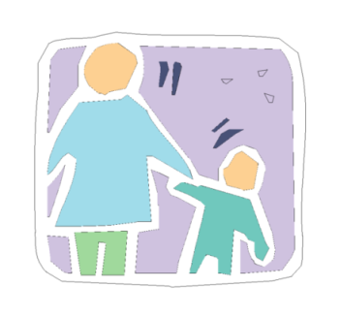

5

**Things You Can Do To**

**Prevent Lead Poisoning**

**1**

**Learn the facts**

Lead poisoning is very dangerous, especially for children

under 6 years old. If you are pregnant, lead can harm your baby.

* Lead can cause serious learning and behavior problems.
* Lead poisoning hurts the brain and nervous system.
* Lead in a child’s body can make it hard to pay attention and learn.
* Some of the effects of lead poisoning may never go away.
* Even a small amount of lead poisoning is harmful.
* It is very important to **prevent** your children from being harmed by lead.

**Keep children away from lead paint & lead dust.**

2

When old paint cracks and peels, it makes lead dust. Lead dust is

so small you cannot see it. Children get lead poisoning from

swallowing dust on their hands and toys.

* Use wet paper towels to clean up any dust which may have lead in it.
* Clean around windows, play areas, and floors often.
* Wash hands and toys often with soap and water. Always wash hands before eating and sleeping.
* Use contact paper or duct tape to cover chipping or peeling paint, and have repairs made promptly.

## Give your child healthy foods

3

Feed your child healthy foods with calcium, iron, and vitamin C.

These foods may help keep lead out of the body.

* Calcium is in milk, yogurt, cheese, and green leafy vegetables like spinach.
* Iron is in lean red meats, beans, peanut butter, and cereals.
* Vitamin C is in oranges, green and red peppers, and juice

**Check your house for lead**

4

Most children get lead poisoning from chipping and peeling lead

paint in homes built before 1978

* It is important to find and fix lead in your home as soon as possible.
* Talk with your landlord about fixing any peeling or chipping paint

### Home repairs like sanding or scraping paint can make dangerous dust. Make sure all repairs are done safely without stirring up lead dust.

* Make sure you and/or any workers are trained in lead-safe work practices.

## Get your child tested for lead

5

A lead test is the only way to know if your child has lead poisoning.

Most children with lead poisoning do not look or act sick.

* Ask your doctor to test your child for lead.
* If your child has a high blood level:
  + Ask questions if you don’t understand something
  + Go Back for a second lead test
  + Test your child for learning and other problems. This is called a “developmental assessment.”

*For more information call:*

Childhood Lead Poisoning Prevention Program, Philadelphia Department of Public Health

**215 685-2788 or 215 685-2797**

**www:Phila.gov/health/childhoodlead**