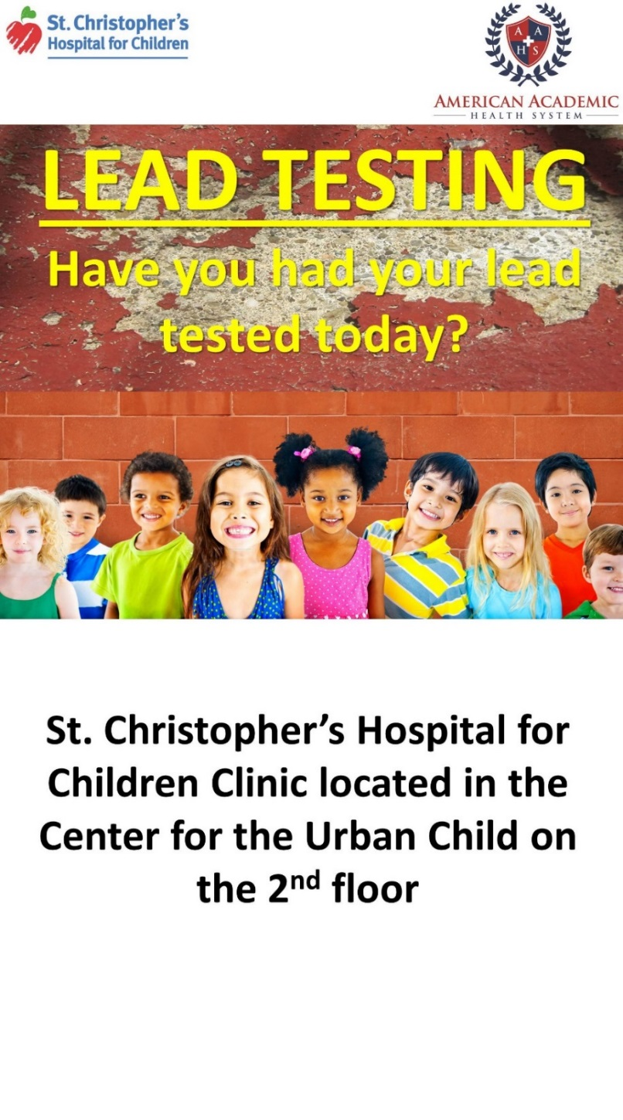

Thank you for getting your child tested for Lead Poisoning today!

* Lead Poisoning is a serious issue and small amounts of lead can cause very serious harm to the brain
* It can affect a child’s growth and development, sometimes permanently

In Philadelphia, 4.2% of children <6 years old have an elevated blood level. This is higher than in Flint, Michigan!

A lead test is the only way to know if your child has lead poisoning

* In a lead test, a blood sample is taken from your child’s finger or arm
* The test measures how much lead is in the blood
* Most children who have lead poisoning do not look or act sick

The lab to get the blood test is on the 2nd floor. Please sign in at the clipboard that is across from the elevator.

Thank you for your patience while you are waiting for your turn to get tested.

To find out more information about Lead Poisoning, use the QR code below:

