
Bike Helmet Sizing Guide 4 Easy Steps
- Measure the head circumference an inch above the ear at the top of the eyebrow for approximate size.
- Grab the appropriate helmet from the photocopy/mail room.
  - SMALL 19.5 inches to 22 inches
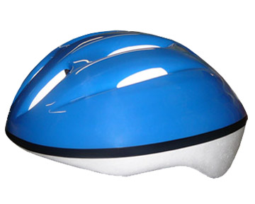
  - MEDIUM 22 to 23 inches
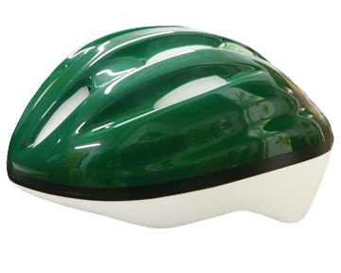
  - LARGE 23 to 24.5 inches
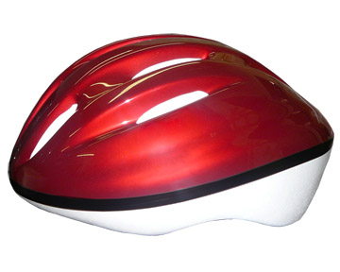
- Helmet should fit on head without rocking back and forth. Sizing pads can be used to adjust the fit to different head shapes. Mix or match the sizing pads to get the best fit.
- The helmet should sit level on the head so that the forehead is covered down to just above the eyebrow - this is called “the halo effect”.
Adapted from www.helmetsrus.net

