THE BUSINESS PLAN

PART II

MARYLEE MUNDELL, DO

GOALS

1. Write the marketing plan component of a business plan.
2. Write the operations and management portion of the business plan.

OBJECTIVES

1. Understand and apply the current available avenues of advertising and marketing to a business plan.
2. Understand the most efficient and effective forms of advertising for a practice.
3. Understand the financial implications of advertising.
4. Develop an infrastructure of personnel for a medical practice.
5. Develop an acquisition plan for new patients.
6. Develop a system for managing and caring for patients in a medical practice.

The Marketing Plan

In today’s world the options for advertising seem endless and exciting. Our technological advancing society is constantly changing and evolving to develop new and different ways to disseminate information to the population at large. Some of these techniques can be very inexpensive and easy to implement. Others can require experts to sift through the multitude of options.

The practice must determine where its target population is and how to contact them in the most effective and cost contained manner. Remember, advertising can be very expensive. The practice must constantly have some form of advertisement. It is critical to maximize the exposure of the practice to the correct audience. This is where the customer analysis is important. Using the results from that research, a useful plan can be formulated.

The first step is to develop a logo for the practice. This is usually recommended by most marketing experts since it helps identify your practice from the competition. The logo should be eye catching and represent the essence of the practice and its staff. Once this is accomplished the other forms of advertising can be implemented.

Next a practice brochure should be developed. This should contain the basic information of the makeup of the practice. The formal name, location, contact numbers, website and email addresses should be listed. Brief resumes of the providers and their philosophies on medical care are a nice touch. Also any specifics as to on call hours and wait times for appointments should be discussed. The advantages of the practice over the competition should be highlighted. The patient should be able to look at the document and have a basic understanding of the medical care providers and the services of the practice.

Advertising can be accomplished through several types of media. The internet has fast become the most popular and cost efficient way. It is no longer enough to place ads on the internet. Now most practices have used other modes that are contained within the web. Podcasts, You-tube and other venues are being developed as a valid source of advertisement. Also daily blogging is fast becoming the new link between practices and the target audiences. Many practices have developed websites that are interactive and post video lectures by physicians and other staff.

The website of the practice should be informative and interactive. The formal name of the practice and locations, contact numbers and email should be included. It should list all of the doctors that practice and any key support staff such as nurse practitioners and physician assistants. Be careful about listing too many staff members since staffing may change and so will your website.

The mission statement of the practice and its philosophy should be discussed. Hours of operations and after hours on call protocols should also be elucidated. HIPPA unfortunately ties the hands of most practices on the content and amount of interactivity that can occur. This may change as the government insists that all practices be electronic within the next decade. Giving medical advice via email is usually frowned upon by most attorneys and HIPPA experts. However a frequently asked questions and answers page is a great way to allow a prospective patient see how you address medical issues. Finally, medical links to pertinent websites can be placed on the website. A list of recommended books for parents can also be added.

Newspaper ads are still a very effective medium for advertising. Unfortunately they tend to be very expensive and costs increase with amount of exposure that they have. Many practices use ads only for certain special occasions or for a grand opening. The same goes for television or radio ads. Cheaper forms of advertising are lecturing to the public, listings on hospital referral lists, and business cards.

The marketing plan needs to be thought out in terms of time and money. Remember the ultimate goal of the marketing plan is revenue enhancement for the practice. The practice should have a five year plan. A budget for the initial advertising should be generous. This usually requires the initial outlay of monies to develop the website, practice logo, brochures and business cards. Letter head for correspondence and writing pads for patient information also must be included. Every practice needs a monthly budget for advertising to continue to reach the target population.

Operations and Management

This section discusses how the business will organize itself and operate. Every practice has a hierarchy of management. The owners are at the top of the pyramid. See figure 1.

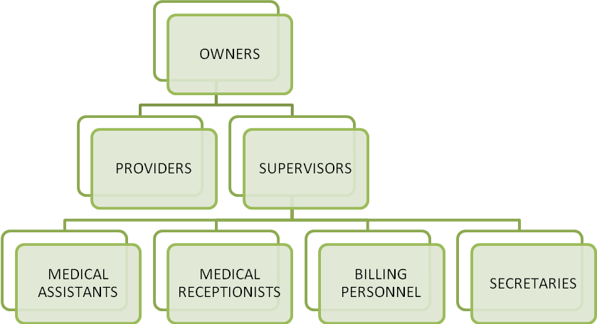

The owners of the practice are usually the officers of the corporation and the board members. This is may also be the physicians. They oversee all major decisions and operations of the practice. Typically the owners hire supervisors to oversee the other employees in the group. A start up practice may require less staff initially. As the practice census grows, the staff required to care for them also must increase. Along with a larger staff comes the need for more supervision.

Job descriptions and duties must be developed and outline all responsibilities for employees. Job descriptions include the tasks performed by that member of the staff in detail. The supervisors are responsible for training and evaluating the employees in their charge. They are also responsible for dissemination of information and new policies to their personnel. The infrastructure of the practice must insure that each level of the practice is managed.

Communication between the levels must be in place for smooth operations. The job descriptions of the supervisors should include a system of communication. This system should delineate the mediums such as verbal, e-mail; inter office mail, EMR to do list etc.

Many practices develop office protocols which allow for seamless training and evaluations. These protocols range from administrative tasks along with billing and financial operations to medical procedures. Protocols are fast becoming the cornerstone for most medical practice operations. They improve the quality of care and decrease the risk of medical errors.

The operations plan of a practice elaborates on the staff needed to care for the patients and also the manner in which the practice will adapt to an increasing patient census. This has a trickledown effect. The increasing patient size requires more staff and a more elaborate hierarchy of management of staff. Administrative and medical requirements go hand in hand in today’s healthcare system.

Administrative needs such as registration of patients, phone triage and processing of referrals must be determined when looking at total administration staffing numbers. The amount of insurance claims that will require processing determines the size of the billing staff. Protocols for accomplishing these tasks must be developed and updated as the practice grows. Also new governmental regulations require constant updates to operations and procedures. OSHA, HIPPA and now Red Flag Rules require appointment of officers within the practice and protocols that must be adhered to.

Consideration toward new patients, Hospital nursery admissions and transfers into the practice must be addressed. These numbers should be analyzed by age of the patient and the insurance that is held. A yearly plan of management of all patients should contain the census, staff required to care for the patients and staff required to run the administrative and billing work load. Quality of care must always be a top priority in determining the number and type of staff that is needed.

Resources

1. [**Job Description: Medical Assistant**](http://practice.aap.org/emailedContent.aspx?emailID=o0t2z61C60j55oo1EEE596F0dpn5n)[**http://practice.aap.org/emailedContent.aspx?emailID=o0t2z61C60j55oo1EEE596F0dpn5n**](http://practice.aap.org/emailedContent.aspx?emailID=o0t2z61C60j55oo1EEE596F0dpn5n)
2. [**Using Web Sites to Market Your Pediatric Practice**](http://practice.aap.org/emailedContent.aspx?emailID=o0t2z9530E735Dj55oo1F2CC21EDdpn5n)[**http://practice.aap.org/emailedContent.aspx?emailID=o0t2z9530E735Dj55oo1F2CC21EDdpn5n**](http://practice.aap.org/emailedContent.aspx?emailID=o0t2z9530E735Dj55oo1F2CC21EDdpn5n)

1. [**Marketing Your Pediatric Practice**](http://practice.aap.org/emailedContent.aspx?emailID=o0t2z9530E735Dj55oo1F278A19Bdpn5n)[**http://practice.aap.org/emailedContent.aspx?emailID=o0t2z9530E735Dj55oo1F278A19Bdpn5n**](http://practice.aap.org/emailedContent.aspx?emailID=o0t2z9530E735Dj55oo1F278A19Bdpn5n)
2. [**Using Patient Flow Patterns**](http://practice.aap.org/emailedContent.aspx?emailID=o0t2z9530E735Dj55oo1F170A8D6dpn5n)[**http://practice.aap.org/emailedContent.aspx?emailID=o0t2z9530E735Dj55oo1F170A8D6dpn5n**](http://practice.aap.org/emailedContent.aspx?emailID=o0t2z9530E735Dj55oo1F170A8D6dpn5n)
3. [**Back Office Training Guide**](http://practice.aap.org/emailedContent.aspx?emailID=o0t2z61C60j55oo1EF98A69Adpn5n)[**http://practice.aap.org/emailedContent.aspx?emailID=o0t2z61C60j55oo1EF98A69Adpn5n**](http://practice.aap.org/emailedContent.aspx?emailID=o0t2z61C60j55oo1EF98A69Adpn5n)

Assignment

1. Formulate
   1. A five year marketing plan for your business. This should include all forms of advertisement that will be used along with the cost of each part and the length of time it will be implemented. Each group will be given 20,000$ to spend over a five year period.
   2. A logo for the practice.
   3. A website. List all of the information that will be available on the site.
   4. A brochure. Develop an actual brochure and have a hard copy available for hand out at your presentation.
   5. Develop business cards and appointment cards. Again have a hard copy available for your presentation.
2. Develop a patient census. Each practice will have an initial census of 500 patients. Each group should develop a census breakdown of patients and assign them to the insurance companies assigned in the last module. You may create your census to have any ages but the insurances must correspond to your assignment for the group.
3. Develop a hierarchy for your staff. Each group will have three physicians or providers. With your census in mind develop a five year plan that will take into account new patient census and the staff required to provide care and administrative support. The plan can include receptionist, medical assistants, nurses, billing and supervisors. Remember initially you will not have a lot of capital to pay staff. Judge accordingly and slowly increase staff as your census numbers grow. You may choose to increase your numbers at any rate. The hierarchy should include job descriptions with a list of duties.
4. Develop a strategy for operations of the business. This needs to include :
   * + A protocol for registering patients at the front desk. Develop a strategy for collecting copayments and accessing patient information at the front desk.
     + A protocol for work up of the patients by the medical assistants or nurses. Describe how a staff member will ready a patient for a well and a sick visit.(growth measurements, throat cultures, urine samples, immunizations and lab protocols)
     + A telephone protocol for obtaining and documenting calls from patients. Describe the information that will be taken from the parent and the manner in which a staff member will respond.